Clustering
Clustering is the partitioning of data into groups. The two most popular ways used for clustering are K-means and hierarchical clustering. For a data frame, a clustering algorithm finds out which rows are similar to each other. So, it is a good idea to remove columns that are too correlated.

Hierarchical Clustering
Hierarchical clustering builds clusters within clusters. It does not require a prespecified number of clusters. It can be thought as tree and displayed as a dendrogram. At the top there is just one cluster and at the bottom each observation is an entire cluster. Hierarchical clustering works with both numerical and categorical data. Each observation starts as its own cluster. Clusters are then combined, two at a time, until all clusters are merged into a single cluster. Cluster analysis is a data-reduction technique designed to uncover subgroups of observations within a dataset. It allows you to reduce a large number of observations to a much smaller number of clusters or types. A cluster is defined as a group of observations that are more similar to each other than they are to the observations in other groups. Cluster analysis is widely used in the biological and behavioral sciences, marketing, and medical research.

For hierarchical clustering, there are many clustering algorithms to choose from. The most popular are single linkage, complete linkage, average linkage, centroid, and Ward’s method.

Common steps in cluster analysis
Choose appropriate attributes
Scale the data.
Screen for outliers
Calculate distances
Select a clustering algorithm
Obtain one or more cluster solutions.
Determine the number of clusters present
Obtain a final clustering solution using the number of clusters found in the previous step.
Interpret the clusters
Validate the results.

Calculating distances
Every cluster analysis begins with the calculation of a distance, dissimilarity, or proximity between each entity to be clustered. The Euclidean distance between two observations is given by
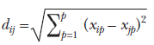

where i and j are observations and P is the number of variables.

For discussion in this presentation make sure that you install cluster, NbClust, flexclust, fMultivar, ggplot2, and rattle packages.
Example: Consider the nutrient dataset provided with the flexclust package.

 | energy | protein | fat | calcium | iron
BEEF BRAISED | 340 | 20 | 28 | 9 | 2.6
HAMBURGER | 245 | 21 | 17 | 9 | 2.7
BEEF ROAST | 420 | 15 | 39 | 7 | 2
BEEF STEAK | 375 | 19 | 32 | 9 | 2.6
BEEF CANNED | 180 | 22 | 10 | 17 | 3.7
CHICKEN BROILED | 115 | 20 | 3 | 8 | 1.4
CHICKEN CANNED | 170 | 25 | 7 | 12 | 1.5
BEEF HEART | 160 | 26 | 5 | 14 | 5.9
LAMB LEG ROAST | 265 | 20 | 20 | 9 | 2.6
LAMB SHOULDER ROAST | 300 | 18 | 25 | 9 | 2.3
SMOKED HAM | 340 | 20 | 28 | 9 | 2.5
PORK ROAST | 340 | 19 | 29 | 9 | 2.5
PORK SIMMERED | 355 | 19 | 30 | 9 | 2.4
BEEF TONGUE | 205 | 18 | 14 | 7 | 2.5
VEAL CUTLET | 185 | 23 | 9 | 9 | 2.7
BLUEFISH BAKED | 135 | 22 | 4 | 25 | 0.6
CLAMS RAW | 70 | 11 | 1 | 82 | 6
CLAMS CANNED | 45 | 7 | 1 | 74 | 5.4
CRABMEAT CANNED | 90 | 14 | 2 | 38 | 0.8
HADDOCK FRIED | 135 | 16 | 5 | 15 | 0.5
MACKEREL BROILED | 200 | 19 | 13 | 5 | 1
MACKEREL CANNED | 155 | 16 | 9 | 157 | 1.8
PERCH FRIED | 195 | 16 | 11 | 14 | 1.3
SALMON CANNED | 120 | 17 | 5 | 159 | 0.7
SARDINES CANNED | 180 | 22 | 9 | 367 | 2.5
TUNA CANNED | 170 | 25 | 7 | 7 | 1.2
SHRIMP CANNED | 110 | 23 | 1 | 98 | 2.6

Euclidean distance between the first two (beef braised and hamburger) is

The dist() function in the base R installation can be used to calculate the distances between all rows (observations) of a matrix or data frame. The format is dist(x,method=), where x is the input data and method="euclidean" by
default.

Example: Load nutrients data

data(nutrient, package="flexclust")
d <- dist(nutrient)
as.matrix(d)[1:6,1:6]

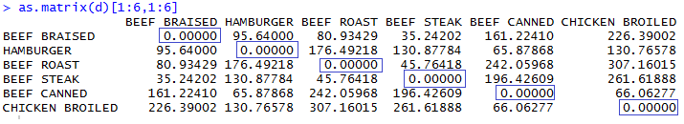

Larger distances indicate larger dissimilarities between observations. The distance between an observation and itself is 0. Note that distances in the nutrient data frame are heavily dominated by the contribution of the energy variable, which has a much larger range. Scaling the data will help

Euclidean distances are usually the distance measure of choice for continuous data. But if other variable types are present, alternative dissimilarity measures are required. You can use the daisy() function in the cluster package to obtain a dissimilarity matrix among observations that have any combination of binary, nominal, ordinal, and continuous attributes.

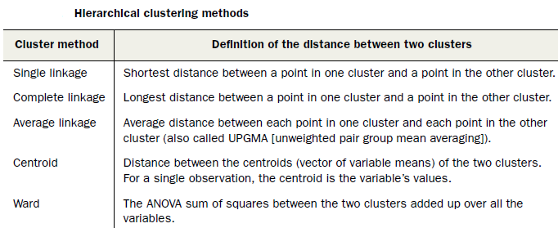

Hierarchical clustering can be accomplished with the hclust() function. The format is hclust(d, method=), where d is a distance matrix produced by the dist()function and methods include "single", "complete", "average", "centroid", and "ward".

The hclust() function takes as input a distance matrix (as an object of class dist), which records the distances between all pairs of points in the data (using any one of a variety of metrics). It returns a dendrogram: a tree that represents the nested clusters. hclust() uses one of a variety of clustering methods to produce a tree that records the nested cluster structure. You can compute the distance matrix using the function dist().

hclust() can be used with one of the following values for the method option:

method | the agglomeration method to be used. This should be (an unambiguous abbreviation of) one of"ward.D", "ward.D2", "single", "complete", "average" (= UPGMA), "mcquitty" (= WPGMA), "median" (= WPGMC) or "centroid" (= UPGMC).

Examle-1: How food types are similar or different with regard to their nutrients?

library(flexclust)
data(nutrient, package="flexclust")
nutrient.scaled <- scale(nutrient)
d <- dist(nutrient.scaled)
fit.average <- hclust(d, method="average")
plot(fit.average, hang=-1, cex=.5, main="Linkage Clustering")

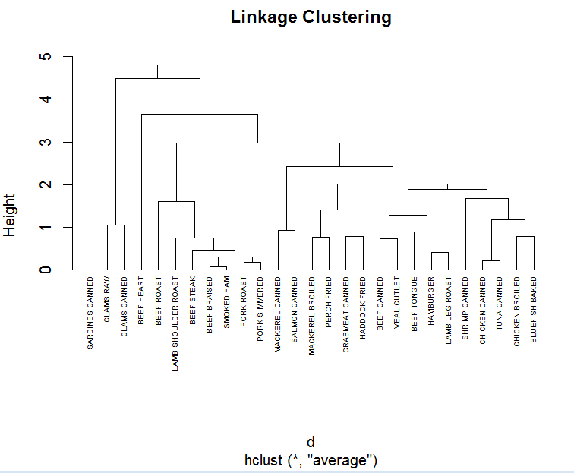

The hang option in the plot() function justifies the observation labels (causing them to hang down from 0).

NbClust Package
The NbClust package offers numerous indices for determining the best number of clusters in a cluster analysis. There is no guarantee that they will agree with each other. In fact, they probably won’t. But the results can be used as a guide for selecting possible candidate values for K, the number of clusters. Input to the NbClust() function
includes the matrix or data frame to be clustered, the distance measure and clustering method to employ, and the minimum and maximum number of clusters to consider. It returns each of the clustering indices, along with the best number of clusters proposed by each.

Selecting the number of clusters
When apply NbClust to find out the number clusters:

numberOfClusters <- NbClust(nutrient.scaled, distance="euclidean", min.nc=2, max.nc=16, method="average")

The result of this line of code is the following 4 plots with a detailed explanation:

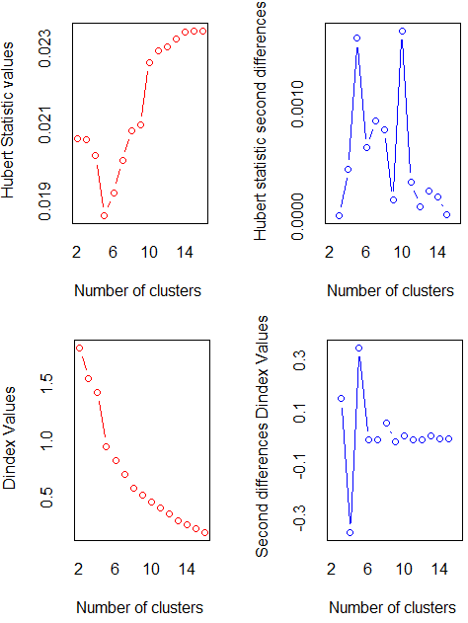

*** : The Hubert index is a graphical method of determining the number of clusters.
In the plot of Hubert index, we seek a significant knee that corresponds to a
significant increase of the value of the measure i.e the significant peak in Hubert
index second differences plot.

*** : The D index is a graphical method of determining the number of clusters.
In the plot of D index, we seek a significant knee (the significant peak in Dindex
second differences plot) that corresponds to a significant increase of the value of
the measure.

*******************************************************************
* Among all indices:
* 4 proposed 2 as the best number of clusters
* 4 proposed 3 as the best number of clusters
* 2 proposed 4 as the best number of clusters
* 4 proposed 5 as the best number of clusters
* 1 proposed 9 as the best number of clusters
* 1 proposed 10 as the best number of clusters
* 2 proposed 13 as the best number of clusters
* 1 proposed 14 as the best number of clusters
* 4 proposed 16 as the best number of clusters

***** Conclusion *****

* According to the majority rule, the best number of clusters is 2

*******************************************************************

What is the next step?
You could try the number of clusters (2, 3, 5, and 16) with the most “votes” and select the one that makes the most interpretive sense.

Example 2: To demonstrate clustering, we’ll use a small dataset from 1973 on protein consumption from nine different food groups in 25 countries in Europe. The goal is to group the countries based on patterns in their protein consumption.

Country | RedMeat | WhiteMeat | Eggs | Milk | Fish | Cereals | Starch | Nuts | Fr&Veg
Albania | 10.1 | 1.4 | 0.5 | 8.9 | 0.2 | 42.3 | 0.6 | 5.5 | 1.7
Austria | 8.9 | 14 | 4.3 | 19.9 | 2.1 | 28 | 3.6 | 1.3 | 4.3
Belgium | 13.5 | 9.3 | 4.1 | 17.5 | 4.5 | 26.6 | 5.7 | 2.1 | 4
Bulgaria | 7.8 | 6 | 1.6 | 8.3 | 1.2 | 56.7 | 1.1 | 3.7 | 4.2
Czechoslovakia | 9.7 | 11.4 | 2.8 | 12.5 | 2 | 34.3 | 5 | 1.1 | 4
Denmark | 10.6 | 10.8 | 3.7 | 25 | 9.9 | 21.9 | 4.8 | 0.7 | 2.4
E Germany | 8.4 | 11.6 | 3.7 | 11.1 | 5.4 | 24.6 | 6.5 | 0.8 | 3.6
Finland | 9.5 | 4.9 | 2.7 | 33.7 | 5.8 | 26.3 | 5.1 | 1 | 1.4
France | 18 | 9.9 | 3.3 | 19.5 | 5.7 | 28.1 | 4.8 | 2.4 | 6.5
Greece | 10.2 | 3 | 2.8 | 17.6 | 5.9 | 41.7 | 2.2 | 7.8 | 6.5
Hungary | 5.3 | 12.4 | 2.9 | 9.7 | 0.3 | 40.1 | 4 | 5.4 | 4.2
Ireland | 13.9 | 10 | 4.7 | 25.8 | 2.2 | 24 | 6.2 | 1.6 | 2.9
Italy | 9 | 5.1 | 2.9 | 13.7 | 3.4 | 36.8 | 2.1 | 4.3 | 6.7
Netherlands | 9.5 | 13.6 | 3.6 | 23.4 | 2.5 | 22.4 | 4.2 | 1.8 | 3.7
Norway | 9.4 | 4.7 | 2.7 | 23.3 | 9.7 | 23 | 4.6 | 1.6 | 2.7
Poland | 6.9 | 10.2 | 2.7 | 19.3 | 3 | 36.1 | 5.9 | 2 | 6.6
Portugal | 6.2 | 3.7 | 1.1 | 4.9 | 14.2 | 27 | 5.9 | 4.7 | 7.9
Romania | 6.2 | 6.3 | 1.5 | 11.1 | 1 | 49.6 | 3.1 | 5.3 | 2.8
Spain | 7.1 | 3.4 | 3.1 | 8.6 | 7 | 29.2 | 5.7 | 5.9 | 7.2
Sweden | 9.9 | 7.8 | 3.5 | 24.7 | 7.5 | 19.5 | 3.7 | 1.4 | 2
Switzerland | 13.1 | 10.1 | 3.1 | 23.8 | 2.3 | 25.6 | 2.8 | 2.4 | 4.9
UK | 17.4 | 5.7 | 4.7 | 20.6 | 4.3 | 24.3 | 4.7 | 3.4 | 3.3
USSR | 9.3 | 4.6 | 2.1 | 16.6 | 3 | 43.6 | 6.4 | 3.4 | 2.9
W Germany | 11.4 | 12.5 | 4.1 | 18.8 | 3.4 | 18.6 | 5.2 | 1.5 | 3.8
Yugoslavia | 4.4 | 5 | 1.2 | 9.5 | 0.6 | 55.9 | 3 | 5.7 | 3.2

One way to try to make the clustering more coordinate-free is to transform all the columns to have a mean value of 0 and a standard deviation of 1. You can scale the data in R using the function scale(). F

Read Data
protein <- read.table(“protein.txt”, sep="\t", header=TRUE)

Use all the columns except the first (Country).
variablesToUSe<- colnames(protein)[-1]

Scale Data
Apply scale() function. Note that the output of scale() is a matrix.
proteinMatrix <- scale(protein[,variablesToUSe])

Calculate Distance
Use Euclidean distance in dist() method
d <- dist(proteinMatrix, method="euclidean")

Obtain a Cluster Solution
clusterUsingWard <- hclust(d, method="ward.D")

Plot Dendrogram
plot(clusterUsingWard, hang=-1, cex=.9, main="Ward-Linkage Clustering",labels=protein$Country)

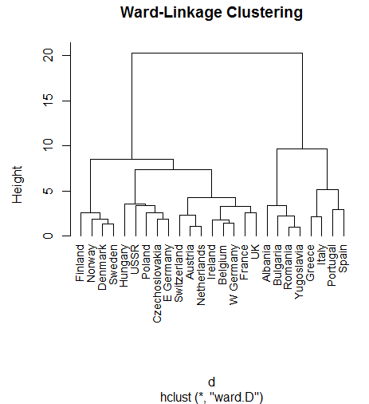

Find Number of Clusters
Use ward.D method in the function NbClust

proteinDataNumberOfClusters <- NbClust(proteinMatrix, distance="euclidean", min.nc=2, max.nc=12, method="ward.D")

Here is the output of the above command:

*******************************************************************
* Among all indices:
* 6 proposed 2 as the best number of clusters
* 7 proposed 3 as the best number of clusters
* 1 proposed 4 as the best number of clusters
* 1 proposed 5 as the best number of clusters
* 3 proposed 6 as the best number of clusters
* 1 proposed 7 as the best number of clusters
* 4 proposed 12 as the best number of clusters

***** Conclusion *****

* According to the majority rule, the best number of clusters is 3

*******************************************************************

The output suggest the bets number of clusters to be 3. Note that this might not be the best option one that makes the most interpretive sense.

You can draw the rectangles on the dendrogram using the function rect.hclust():
rect.hclust(clusterUsingWard, k=3)

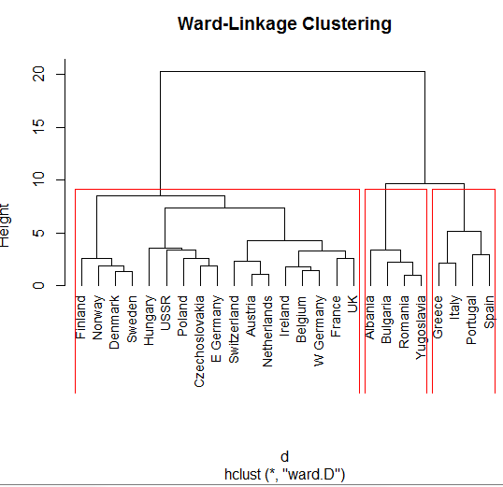

VISUALIZING CLUSTERS
Visualization is an effective way to get an overall view of the data, or in this case, the clusters. We can try to visualize the clustering by projecting the data onto the first two principal components of the data. We’ll use the prcomp() call to do the principal components decomposition.

Principal components analysis (PCA) is a data-reduction technique that transforms a larger number of correlated variables into a much smaller set of uncorrelated variables called principal components. For example, you might use PCA to transform 30 correlated (and possibly redundant) environmental variables into 5 uncorrelated composite variables that retain as much information from the original set of variables as possible.

Suppose that we wish to visualize n observations with measurements on a set of p features, X1,X2, . . .,Xp, as part of an exploratory data analysis. We could do this by examining two-dimensional scatterplots of the data, each of which contains the n observations’ measurements on two of the features. However, there are p(p−1)/2 such scatterplots; for example, with p = 10 there are 45 plots! If p is large, then it will certainly not be possible to look at all of them; moreover, most likely none of them will be informative since they each contain just a small fraction of the total
information present in the data set. Clearly, a better method is required to visualize the n observations when p is large. In particular, we would like to find a low-dimensional representation of the data that captures as much of
the information as possible. For instance, if we can obtain a two-dimensional representation of the data that captures most of the information, then we can plot the observations in this low-dimensional space. PCA provides a tool to do just this. It finds a low-dimensional representation of a data set that contains as much as possible of the variation. The idea is that each of the n observations lives in p-dimensional space, but not all of these dimensions are equally interesting. PCA seeks a small number of dimensions that are as interesting as possible, where the concept of interesting is measured by the amount that the observations vary along each dimension. Each of the dimensions found by PCA is a linear combination of the p features.

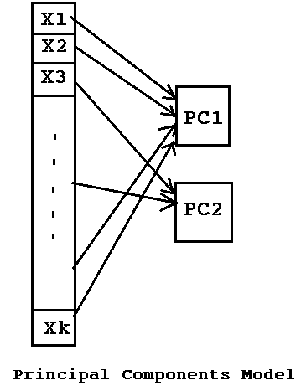

The goal of PCA is to replace a large number of correlated variables with a smaller number of uncorrelated variables while capturing as much information in the original variables as possible.

There are multiple ways to perform principal components analysis in R.

You can use prcomp() from R base packages or the principal()function from library psych.

prcomp()
Performs a principal components analysis on the given data matrix and returns the results as an object of class prcomp.

Example: Use the data USArrests that comes with R base installation. To view data, just type View(USArrests) at R command prompt.

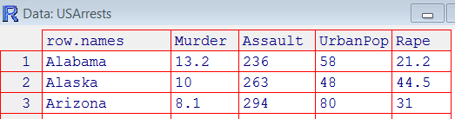

prcomp(USArrests, scale = TRUE)

plot(prcomp(USArrests,scale = TRUE))

summary(prcomp(USArrests, scale = TRUE))

biplot(prcomp(USArrests, scale = TRUE))

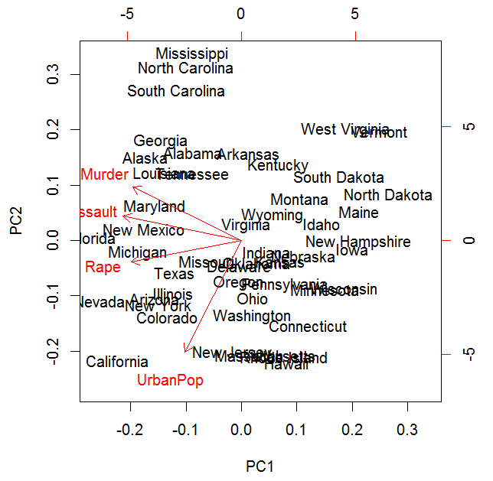

principal()

The format for principal() function is
principal(r, nfactors=, rotate=, scores=)
where
■ r is a correlation matrix or a raw data matrix.
■ nfactors specifies the number of principal components to extract (1 by default).
■ rotate indicates the rotation to be applied (varimax by default)
■ scores specifies whether to calculate principal component scores (false by default).

